1. **Agenda**:
   1. We will try to generalize two Gherkin Steps into one. Thus smart coding.
2. 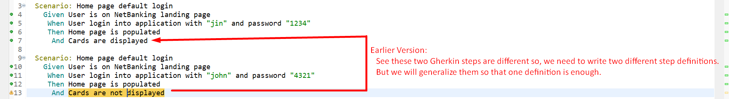
3. Text

   Description automatically generated
4. 